Landscapes Perspectives through Sound and Sight
Time Needed: at least 90 minutes. Can take place over repeated meetings

Resources you will need:
  - Cameras and phones, paper, pens,
  - Musical instruments and recording devices (eg phones)
  - Space and permissions
  - Anti-bacterial wipes and gel
  - The preparation and consent detailed in other worksheets on this site

Elements of a session plan:
Introductions: to each other and the session, consent (sign forms as needed), anonymity, confidentiality, safeguarding and data protection

Awaken enthusiasm
Walk to a nearby outdoor area and explore. What can you see? What can you touch? How does it feel?
Or, Share two inspiring photos – one wide landscape, one small detail. Discuss what you like about them. What might they mean? See photos on the next page as an example.

Cocreate a focus
Decide on a prompt question to guide photography or music making and discuss why e.g.:
- Feelings about places?
- Relationships to places or species?
- A landscape concern?
- An environmental, community or personal need?

Explore with support
Identify roles to support people’s exploration of space in ways that you have risk assessed
Share creative resources and give any technical and artistic help
Encourage people to support each other

Deepen understanding
Create an opportunity for people to share and discuss their creations.
What do people want to share? What do their creations mean?
Who needs to see or hear which creations and understand their meaning?

Follow up (with everyone involved and new stakeholders)
- Before people leave explain, and decide together, about how and when to connect to stakeholders to share creations and messages?
- If you have time look at ideas for dialogue: How can you discuss action with these stakeholders? Change happens more through two way discussion?
- Explain how you will feedback to participants so they know what has happened and so that they can continue to take action with their creations?
Belthorn Collective Example

We used the prompt question: What is important to you in the natural spaces around you?
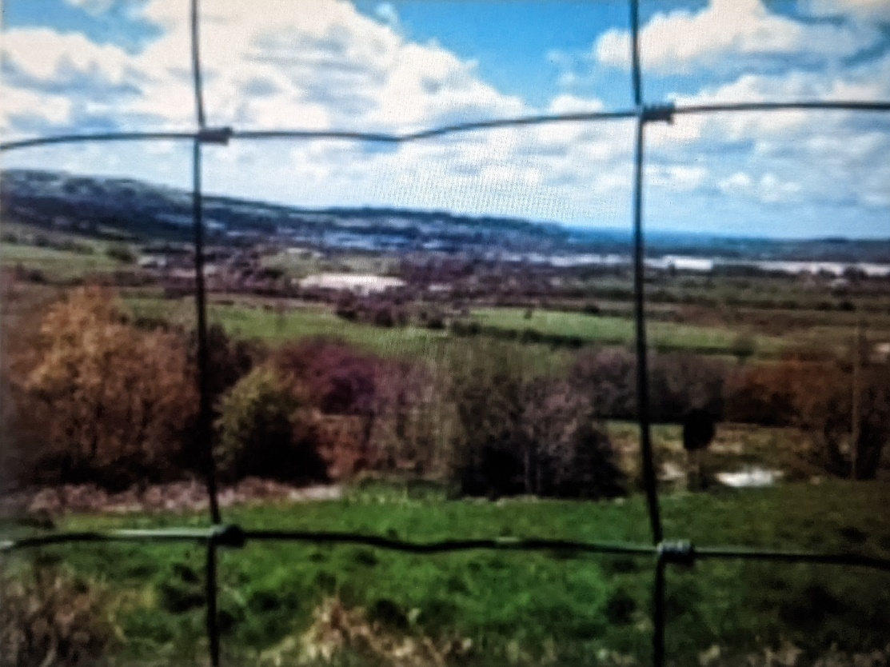

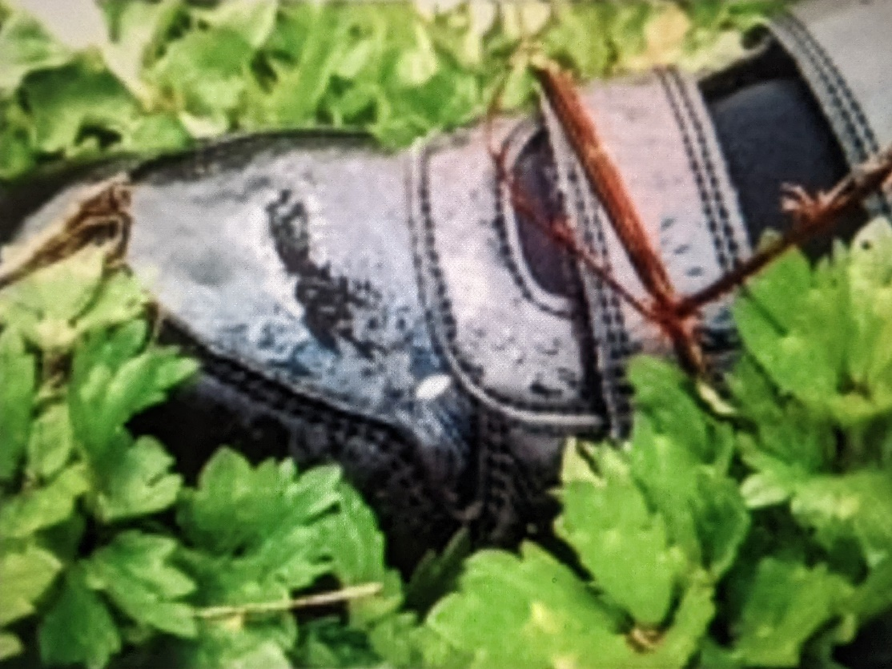
The photos and music created spoke of the need to ensure that children can access green spaces and the opportunity of freedom. Example messages for decision makers were:
- Bring more activities like Forest Schools into education environments so that children get experience of outdoor spaces.
- Protect the open green spaces that are near the places where children live.

